INFORMATION AND COMMUNICATION DIRECTORATE
FACT SHEET
AFRICAN UNION LIBRARY

About the AU Library | 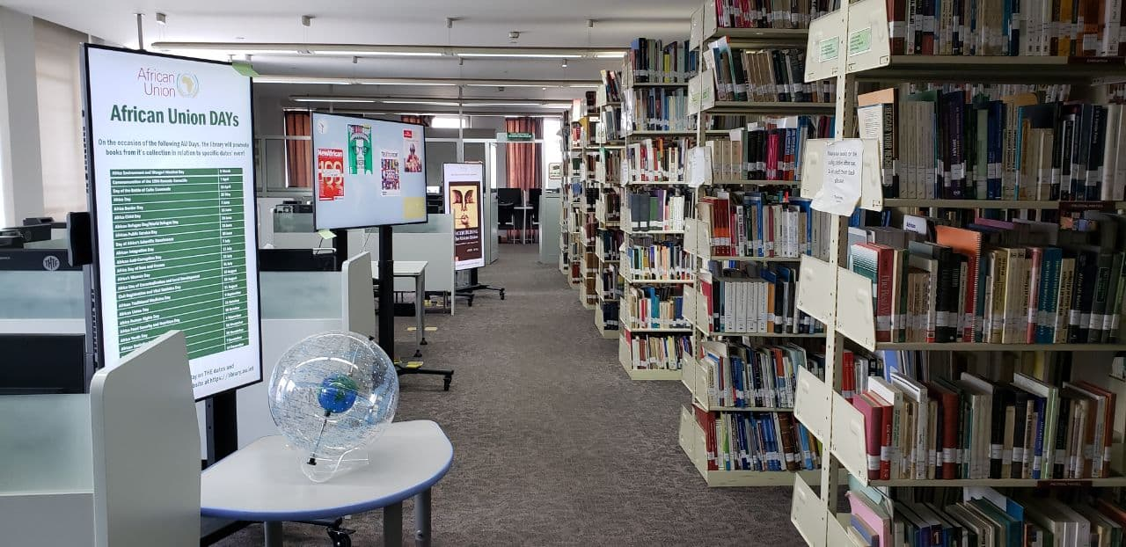  The African Union Library was created to provide timely and relevant sources of information and to promote learning and enhance knowledge required by the staff of the African Union, Member States as well as other users accessing its services.  The AU Library’s is one of units of the Information and Communication Directorate, and plays a key role in delivering the Directorate’s goal of building a knowledge based institution. The AU Library aims specifically to:  - Build and preserve unparalleled sources of information related to Africa for current and future generations.  - Acquire, organise and make available, and/or virtually accessible, a comprehensive collection of historical and current information sources related to Africa in print and digital format in the official languages of the AU;  - Proactively disseminate pertinent and timely information to its patrons; keeping them abreast of current developments in the continent, and the globe in general.  Located on the NCC Building within the AU Head Quarters in Addis Ababa, Ethiopia; the Library provides a wide array of publications and electronic resources in a contemporary, friendly, service oriented environment, complemented with modern technology to enhance user experience.  The AU Library provides a conducive reading and research environment, with over 65 desktop computers with internet connectivity to the Internet providing access to over 40,000 book titles, monographs and a variety of regional and international magazines and research journals.  The AU Library possesses over 60,000 records, including Journal articles, dating back to 1901; as well as a collection of Africa’s 100 best books of the 20th Century.
Who are the Audience for the Library? | - Staff of the AU and AU Member States Embassies (and their families) in Addis Ababa, Ethiopia.  - AU development partners, and researchers from within and outside Africa working on African issues.  - The public at large accessing the AU Library resources on site in Addis Ababa.
AU Library Digital resources | 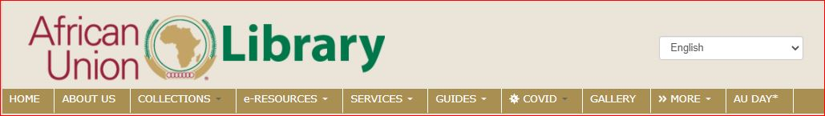  The AU library can be accessed through its website https://library.au.int which provides unlimited access to its vast resources. Through the website users can access the collection of publications as well as access other services including:  - Request for photocopies (scanned copies) of articles from the Library’s resources; register to get email alerts on new arrivals, areas of subject interests and other news about the Library  - Access resources pertaining to a particular region of the continent through interactive maps in the COLLECTIONS tab  - Make recommendations on books using either https://library.au.int/book-recommendation or clicking on the SERVICES tab / Recommend Book(s);  - Receive updates on issues of continental importance such as peace and security of public health information e.g., Covid-19 related information are continuously harvested from renowned publishers and made accessible through the COVID tab https://library.au.int/covid_19  - Subscribe to select service providers (for AU staff through the intranet) by Clicking the Library’s link on the AUC main gadgets) selecting “IGI Global”, or https://library.au.int/igi-global-ebook-access  - Access journals and magazine to which the AU Library subscribed These include PressReader (https://www.pressreader.com) with over 8000 current Newspapers / Newsletters and magazines published globally; the World Bank library (https://elibrary.worldbank.org); The Economist Intelligence Unit’s (EIU) Country Reports  - Access resources from HINARI, OARE, and AGORA as part of the global partnership at http://www.research4life.org/  - HINARI – Links to world's largest collections of biomedical and health literature (established by WHO); over 8500 journals and 7000 e-books in 30 languages http://www.emro.who.int/information-resources/hinari/hinari.html  - AGORA: Global Online Research in Agriculture http://www.emro.who.int/information-resources/hinari/hinari-access.html. Access to more than 3000 journals to institutions in 106 countries with collection in the fields of food, agriculture, environmental science and related social sciences, and provides;  - OARE – Essential resources on environment, including ecology, geography, energy, etc.: https://login.research4life.org/tacsgr1portal_research4life_org/content/oare  - JSTO provides vast resources (Search journals, primary sources, and books), https://www.jstor.org/ -
The African Knowledge Sharing Platform (AKSP): | The African Knowledge Sharing Platform (AKSP) was designed to bring together and make accessible current and historical publications of the African Union, the Regional Economic Communities, as well as other African affiliated organizations’ publications (both within and outside Africa), through the AKSP (https://akb.au.int). This is being undertaken through cooperation of the concerned organizations.  The AKSP aims to:  - Increase search and discovery of the great wealth of information and knowledge on Africa, whose existence and visibilities are hindered by various factors;  - Enhance access to and usage of African related sources of information and knowledge by academicians, researchers, policy makers, etc.  - Contribute towards the development and management of African local content and indigenous knowledge.  The AKSP consists of over 53,000 records (over 19,000 and 34,000 records from the African Union and partners in AKSP, respectively). Some of the Regional, Continental and International partners collaborating in making their publications on Africa accessible through the AKSP , including African Regional Economic Communities (RECs), the University of South Africa (UNISA), the African Centre for the Constructive Resolution of Disputes (ACCORD), the African Development Bank (AfDB), and other United Nations (UN) Agencies.
Contact Department: | Information and Communication Directorate (ICD)

