                                                                                                                                                                                                                                                                                                      

**INFORMATION & COMMUNICATION DIRECTORATE**

**Press Release No:**  208/2024**Date:**21 November 2024

**Venue:**Nairobi, Kenya

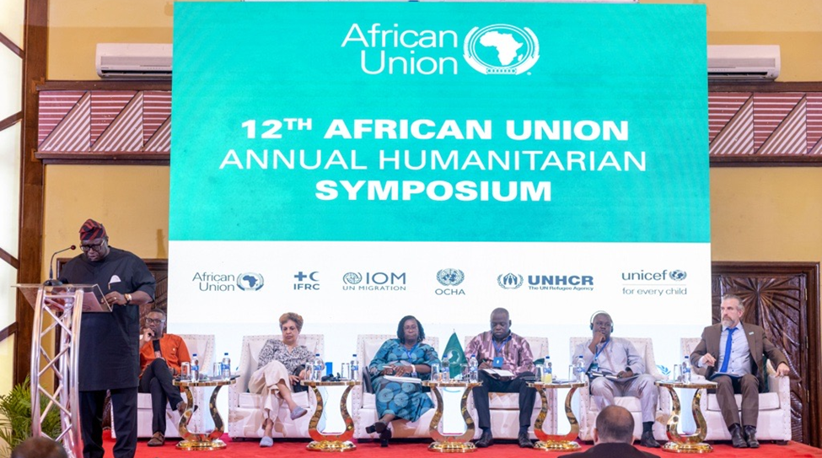 **Contextually appropriate responses are critical in addressing plight of children in humanitarian crises: AU Annual Humanitarian Symposium.**

The African Union Annual Humanitarian Symposium has concluded its reflection on the current humanitarian support extended to children and adolescents in crisis situations and deliberated on innovative ways to address existing and emerging challenges that threaten the welfare and wellbeing of children. Currently, it is estimated that 45 million children in Africa are in urgent need of humanitarian assistance from situations triggered by armed conflict, climate change, economic instability, and public health challenges.

Conflict zones, particularly in Sudan, the Democratic Republic of Congo, and the Sahel region, have seen severe disruptions to children's and adolescents’ lives, often resulting in family separations, denial of education, and increased exposure to violence, exploitation, child labor, conscription as child soldiers and many other forms of abuse. ­ The conflict in Sudan and the Sahel region, have left millions of people are displaced due to armed insurgencies, while in the Horn of Africa, which is bearing the brunt of the impacts of repeated climate crises, including droughts, floods and locust invasions, have caused severe food insecurity and massive displacement.

Reports by development organizations show that in Eastern and Southern Africa, 45 million children require humanitarian assistance due to El Niño-induced climatic shocks, cholera outbreaks, economic deterioration, civil unrest, and population displacements. While in West and Central Africa, 48.4 million children are in humanitarian situation due to conflicts, population movements, public health emergencies, food and nutrition crises, and climate change-related disasters.

With children constituting over 60% of the forcibly displaced persons in Africa, child protection becomes a critical concern. The four day meeting that brought together the African Union, policy makers from the 55 member states, development partners, academia, think tanks, civil society organizations, and children who shared their lived experiences as refugees, Internally Displaced Persons, and stateless persons, was crucial to advance an integrated and holistic approach to address the immediate needs of children, protect them from harm, and provide them with the tools to become agents of change in their societies. The meeting explored among others, the avenues for:

1. Immediate humanitarian assistance that prioritizes the provision of food, shelter, health care, and psychosocial support for emotional well-being.
2. Family reunification and protection and the urgency to strengthen efforts to prevent family separation and reunite displaced children with their guardians.
3. Child protection through improved community protection systems to prevent the exploitation, abuse, and recruitment of children by armed groups.
4. Youth empowerment through provision of opportunities for young people to participate in decision-making and the rebuilding of their communities.
5. Enhanced partnerships that foster cooperation between governments, civil society and international organizations for a coordinated humanitarian response.
6. Resource mobilization for adequate funding to support these vital initiatives.

Reaffirming the commitment by the African Union to protect the future of Africa's children and adolescents, H.E. Minata Samate Cessouma, African Union Commissioner of Health, Humanitarian Affairs and Social Development, underscored the need for synergy and coordinated efforts by stakeholders to address the plight of the children and accord them an environment where they can thrive, regardless of the crises they face. She stated, “In the face of these harsh realities, it is imperative to remember that children do not choose to be born in a context of conflict or crisis. They must not be left behind in our humanitarian efforts. The African Union, in partnership with its Member States and partners, is committed to ensuring not only the protection of these children and adolescents, but also to providing them with the opportunities they need to thrive despite the challenges they face.”

Hon. Wilson Almeida Adão, Chairperson of the [African Committee of Experts on the Rights and Welfare of the Child](https://eur03.safelinks.protection.outlook.com/?url=https%3A%2F%2Fwww.acerwc.africa%2Fen&data=05%7C02%7CSolomonF%40africa-union.org%7C25fa7288e56e4307be6708dd0f8c5514%7C4f56f714477c44a1a135a2fb27680aaf%7C0%7C0%7C638683817822407775%7CUnknown%7CTWFpbGZsb3d8eyJFbXB0eU1hcGkiOnRydWUsIlYiOiIwLjAuMDAwMCIsIlAiOiJXaW4zMiIsIkFOIjoiTWFpbCIsIldUIjoyfQ%3D%3D%7C0%7C%7C%7C&sdata=875rC6ZNl%2B3GjPlCmaP94U40IqQqonZV0KSdNPNmWUA%3D&reserved=0) (ACERWC) called for robust and responsive interventions that address family tracing and social reintegration, rehabilitation and trauma counselling. The [African Charter on the Rights and Welfare of the Child](https://eur03.safelinks.protection.outlook.com/?url=https%3A%2F%2Fau.int%2Fen%2Ftreaties%2Fafrican-charter-rights-and-welfare-child&data=05%7C02%7CSolomonF%40africa-union.org%7C25fa7288e56e4307be6708dd0f8c5514%7C4f56f714477c44a1a135a2fb27680aaf%7C0%7C0%7C638683817822451723%7CUnknown%7CTWFpbGZsb3d8eyJFbXB0eU1hcGkiOnRydWUsIlYiOiIwLjAuMDAwMCIsIlAiOiJXaW4zMiIsIkFOIjoiTWFpbCIsIldUIjoyfQ%3D%3D%7C0%7C%7C%7C&sdata=FByNdpxFWhfxi%2BBYzaXByiavyLG4LpszwJBgPnPptAQ%3D&reserved=0) under article 22 and 23 of its provisions, underscores the protection of children in conflict situations, and in refugee and displacement settings. He stated, “let us remember that the figures are more than numbers and the experiences are more than stories. They represent the lived realities of children and adolescents. Acknowledging the need for specialised care, assistance, guidance, and education to enable children and adolescents to fully develop their inherent potential in a peaceful and conflict-free environment, let us all commit ourselves to discourse rooted in child rights-based and child-centred approaches. Let us question whether our existing child protection systems are truly fit for purpose.”

H.E. Mamadou Dian Balde, UNHCR Regional Director for East, Horn of Africa and Great Lakes Region made emphasis on the inclusion of refugees in the communities where they have found safety after fleeing conflict and persecution as the most effective way to support them in restarting their lives and enable them to contribute to the countries hosting them. He noted that, “despite increasing displacement, it is important to emphasize that we are also successfully finding solutions for forcibly displaced populations, including through voluntary repatriation, resettlement and complementary pathways, and measures to facilitate local solutions. In 2023, the largest number of refugee returns were to South Sudan, primarily from the Sudan, followed by Nigeria, Burundi, and the Central African Republic. Several countries, including Uganda, Kenya, and Ethiopia, are also making great strides in including refugees in national systems.”

Echoing similar sentiments, H.E. Mahlaba Mamba, Eswatini Permanent Representative to the African Union called for enhanced engagement with local communities to empower them to actively participate in the safeguarding of children and adolescents. Their knowledge, traditions, and experience can offer sustainable solutions ensuring that interventions are culturally sensitive and contextually appropriate. “It is our moral responsibility to ensure that these young lives are protected and given the opportunity they deserve. By addressing the root causes of these crisis and providing appropriate cultural support, we can create an environment that fosters their growth, resilience and development. Local individuals and grassroots organizations have emerged as important actors in bridging the gaps in humanitarian access in Sudan. They understand the urgency and are driven by a deep sense of compassion and solidarity towards their fellow citizens.”

While sharing experiences of Kenya as one of the African Union member states that has opened its borders to refugees and asylum seekers, Mr. Jacob Narengo, Secretary of Internal Security, in Kenya’s Ministry of Interior, underlined the importance of the inclusion of young, displaced people into national systems, in a manner that ensures sustainable protection and solutions responses. He added, “Kenya remains the fifth largest refugee hosting country in Africa with over 890,000 refugees and asylum seekers. The government of Kenya, in line with the Global Compact on Refugees and its comprehensive refugee’s response framework, in collaboration with its partners, has taken concrete steps through several initiatives to improve the socio-economic conditions and inclusion of refuges and support building resilience for the host communities.”

The African Union Annual Humanitarian Symposium was an important platform for stakeholders to reflect and advance actions on improved coordination among humanitarian actors, governments, and local communities to ensure a cohesive approach to child protection, emphasizing that partnerships can maximize resources and impact. Additionally, emphasised on the importance of preparedness and effective coordination mechanisms in humanitarian action, working towards a more inclusive and effective response for all children affected by crises in Africa. An outcome document of the forum was adopted with recommendations on protecting and promoting the rights and welfare of children.

**For further information please contact:**

**Ms. Rita Amukhobu| Head of Humanitarian Affairs Division| E-mail:**[**amukhobur@africa-union.org**](mailto:amukhobur@africa-union.org)

**Ms. Doreen Apollos** | Information and Communication Directorate**|** African Union Commission **|| E-mail:**  [ApollosD@africa-union.org](mailto:ApollosD@africa-union.org)**|**Addis Ababa, Ethiopia.

**Information and Communication** **Directorate,**African Union Commission I **E-mail:** DIC@africa-union.org  
**Web:** au.int**|**Addis Ababa, Ethiopia**| Follow Us:**[Facebook](https://eur03.safelinks.protection.outlook.com/?url=https%3A%2F%2Fwww.facebook.com%2FAfricanUnionCommission&data=05%7C02%7CSolomonF%40africa-union.org%7C25fa7288e56e4307be6708dd0f8c5514%7C4f56f714477c44a1a135a2fb27680aaf%7C0%7C0%7C638683817822482882%7CUnknown%7CTWFpbGZsb3d8eyJFbXB0eU1hcGkiOnRydWUsIlYiOiIwLjAuMDAwMCIsIlAiOiJXaW4zMiIsIkFOIjoiTWFpbCIsIldUIjoyfQ%3D%3D%7C0%7C%7C%7C&sdata=9w8iVWoo9ErYkwJnv%2FGPv58bw6gmHpmopZt%2Fyx4FZpI%3D&reserved=0) |[Twitter](https://eur03.safelinks.protection.outlook.com/?url=https%3A%2F%2Ftwitter.com%2F_AfricanUnion&data=05%7C02%7CSolomonF%40africa-union.org%7C25fa7288e56e4307be6708dd0f8c5514%7C4f56f714477c44a1a135a2fb27680aaf%7C0%7C0%7C638683817822504189%7CUnknown%7CTWFpbGZsb3d8eyJFbXB0eU1hcGkiOnRydWUsIlYiOiIwLjAuMDAwMCIsIlAiOiJXaW4zMiIsIkFOIjoiTWFpbCIsIldUIjoyfQ%3D%3D%7C0%7C%7C%7C&sdata=cG6%2BERbynMYc8niNZXO%2Fzi%2B1S8qapIVrkez8NBMRMxE%3D&reserved=0) |[Instagram](https://eur03.safelinks.protection.outlook.com/?url=https%3A%2F%2Fwww.instagram.com%2Fafricanunion_official%2F&data=05%7C02%7CSolomonF%40africa-union.org%7C25fa7288e56e4307be6708dd0f8c5514%7C4f56f714477c44a1a135a2fb27680aaf%7C0%7C0%7C638683817822525572%7CUnknown%7CTWFpbGZsb3d8eyJFbXB0eU1hcGkiOnRydWUsIlYiOiIwLjAuMDAwMCIsIlAiOiJXaW4zMiIsIkFOIjoiTWFpbCIsIldUIjoyfQ%3D%3D%7C0%7C%7C%7C&sdata=y1ZtjhvVpaHPZ4UsXVCpnVNqhLtJgIZv4DBwQp7ph10%3D&reserved=0) |[YouTube](https://eur03.safelinks.protection.outlook.com/?url=https%3A%2F%2Fwww.youtube.com%2FAUCommission&data=05%7C02%7CSolomonF%40africa-union.org%7C25fa7288e56e4307be6708dd0f8c5514%7C4f56f714477c44a1a135a2fb27680aaf%7C0%7C0%7C638683817822548318%7CUnknown%7CTWFpbGZsb3d8eyJFbXB0eU1hcGkiOnRydWUsIlYiOiIwLjAuMDAwMCIsIlAiOiJXaW4zMiIsIkFOIjoiTWFpbCIsIldUIjoyfQ%3D%3D%7C0%7C%7C%7C&sdata=9DPIpyPnYX9894RZeV9Agf0NPQjm4jC6A3d9AwT%2F7Ac%3D&reserved=0)